**Experiment- 05(b)**

**AIM :** Studying and implementing Cascading Style Sheets(CSS) and styling exp.4 using a separate css file.

**THEORY** :

Cascading Style Sheets(CSS) is a simple mechanism for adding style(e.g. fonts,colors,spacing) to Web documents.

CSS comes in three types:

* In a separate file(external)
* At the top of a web page document(internal)
* Right next to the text it decorates(inline)

In this experiment , we are decorating the web document using the first type of CSS,i.e, the external CSS.

We will create a file “style_b.css” which will have all the styling and will then link that CSS file in our main html file using link tag.

**Screenshot:**

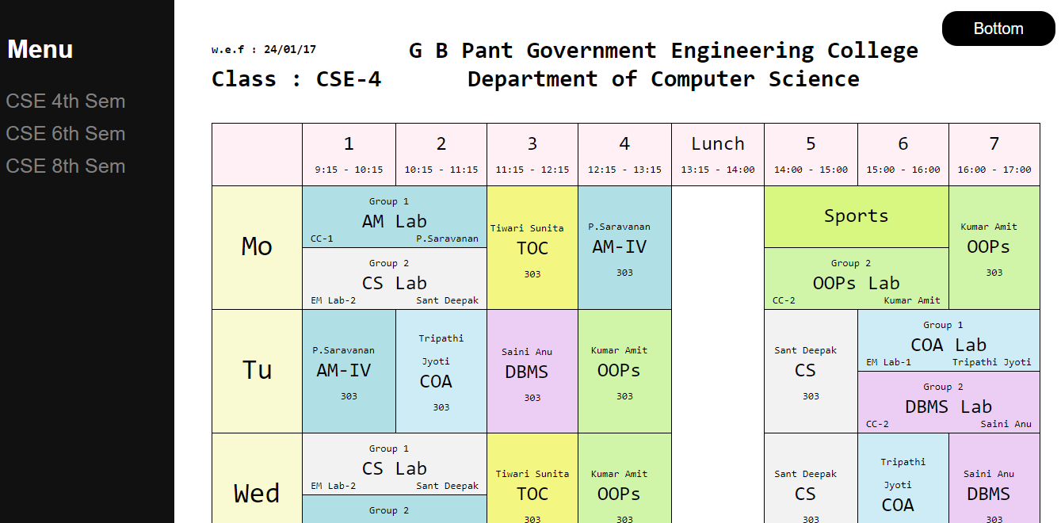

**Fig 5.1: Final Web Document**

**Code Snippet:**

**Uzma_b.html:**

<!DOCTYPE html>

<html>

<head>

<title>Experiment-5(b)</title>

<link rel=”stylesheet” href=”./style_b.css” type=”text/css”>

</head>

<body>

//Body content same as in Experiment 4

</body>

</html>

**Style_b.css :**

body {

font-family: "Lato", sans-serif;

}

tr{

background-color:#FFF0F5;

}

a:hover{

background-color: white;

color:black;

}

table{

border-collapse:collapse;

font-size:25px;

width: 105%;

}

td{

border:1px solid black; padding:10px; width:100px;

}

.td1{

border:1px solid black;padding:0px 10px 4px 10px;

}

.btn_div{

float:right

}

.buttn{

background-color: black;

font-size: 20px;

color: white;border-radius: 19px;

text-decoration: none;

padding: 11px 40px;

}

.menu_div

{

height: 100%;width: 17%;position: fixed;

top: 0;

left: 0;

background-color: #111;

padding-top: 20px;

}

a{

padding: 6px 8px 6px 16px;

text-decoration: none;

font-size: 25px;

color: #818181;

display: block;

}

.menu

{

padding: 4px 18px;

color:white

}

.heading

{

width:88%;

height:100%;

margin:auto;

background-color:white;

font-family: monospace;

font-size:15px;

}

.date{

width:25%;

float:left;

}

.wef

{

margin-top: 28px;

font-weight: bold;

}

.cse

{

margin-top:-5px;

}

.clg_style

{

display: inline-block;

}

.row1

{

background-color:#FAFAD2;

font-size: 36px;

}

.sports

{

border:1px solid black;

padding:20px 10px 20px 10px;

background-color:#ECCEF5;

}

span{

font-size: 13px;

}

span:nth-child(3){

float: right;

}

span:nth-child(2){

float: left;

}